|  |  |  |  |
| --- | --- | --- | --- |
| KIIT(sponsor).png | | | |
|  | | | |
|  | | | |
|  | | | |
| A **MAJOR PROJECT** report on : | | | |
|  | | | |
| **A COMPARATIVE ANALYSIS OF MACHINE LEARNING ALGORITHMS** | | | |
|  | | | |
| submitted in partial fulfilment of the requirements for the degree of | | | |
| B. Tech | | | |
| In | | | |
| **Electronics and Electrical Engineering** | | | |
| By | | | |
|  | |  | |
|  | |  | |
| under the guidance of | | | |
| **Prof. K.B. Ray** | | | |
| |  | | --- | | School of Electronics Engineering | | **KIIT Deemed to be University**  **BHUBANESWAR**  **April 2022** | |  | | | | |
| **CERTIFICATE**  This is to certify that the major project (part – II) report entitled **“A COMPARATIVE ANALYSIS OF MACHINE LEARNING ALGORITHMS”** submitted by   |  |  | | --- | --- | | Souvik Karmakar | 1807228 | | Sudeshna Dutta | 1807232 | | Indrashis Mitra | 1807274 | | Kinjal Sarkar | 1807277 | | Pratyay Basu | 1807291 |   in partial fulfilment of the requirements for the award of the **Degree of Bachelor of Technology** in **Electronics and Electrical Engineering** is a bonafide record of the work carried out under my(our) guidance and supervision at School of Electronics Engineering, KIIT (Deemed to be University). | | | |
|  | Signature of Supervisor 1  Prof.K.B.Ray  School of Electronics Engineering  KIIT (Deemed to be University) | | |
|  | | | |
|  | | | |
| **The Project was evaluated by us on _____________** | | | |
|  | | | |
| EXAMINER 1 | | | EXAMINER 2 |
| EXAMINER 3 | | | EXAMINER 4 |
|  | | |  |
|  | | |  |
|  | | |  |

**ACKNOWLEDGEMENT**

We feel immense pleasure and feel privileged in expressing our deepest and most sincere gratitude to our supervisor **Prof. K.B. Ray**, for her excellent guidance throughout our project work. Her thoughtfulness, devotion, hard work, and attention to detail have been a source of great inspiration for us. Our sincere gratitude to you, ma'am, for your unending support and patience. We would especially want to thank her for her assistance in painstakingly and meticulously revising all of our papers.

We are really grateful to **Prof. Suman Roy,** **Prof. Pravat Biswal**

**Prof. M. Ramana,** FIC project (EEE), Associate Dean **Dr. Amlan Datta,** **Prof. Suprava Pattanaik**, Dean (School Of Electronics) and **Prof. Arun Kumar Ray**, Director (School of Electronics) for their support and suggestions during our course of the project work in the final year of our undergraduate course.

**STUDENT SIGNATURE:-**

|  |  |  |
| --- | --- | --- |
| Roll Number | Name | Signature |
| **1807228** | **Souvik Karmakar** |  |
| **1807232** | **Sudeshna Dutta** |  |
| **1807274** | **Indrashis Mitra** |  |
| **1807277** | **Kinjal Sarkar** |  |
| **1807291** | **Pratyay Basu** |  |

Date:-

**ABSTRACT**

Indian pharmaceutical companies are the world's leading provider of generic medicines. Over 50% of the world's vaccine need is supplied by the Indian pharmaceutical sector, which accounts for 40% of pharmaceuticals needed in the United States and 25% of all medicines in the United Kingdom. Pharmaceutical production in India ranks third globally in terms of volume and fifteenth globally in terms of value. The domestic pharmaceutical industry consists of over 3,000 medical firms and 10,500 production facilities.

India is a major player in the global pharmaceutical sector. There is a large hub of budding engineers and scientists in the nation that can take the business to the next level. Antiretroviral drugs manufactured in India currently account for more than 80% of the world's AIDS medicine supply.

However,people in India are taking desperate steps to keep loved ones alive as a disastrous spike of new coronavirus infections overwhelms the country's health-care infrastructure. They are turning to dubious medical therapies in some circumstances, and to the underground market for life-saving pharmaceuticals in others.

Hence our project aims to solve this by developing a medicine recommendation system so that pharmacists can know in advance what medicines are the medicines being bought together the most,and keep stocks accordingly. We do not recommend which medicine is to be taken,rather the focus is on finding the drug combinations bought frequently together so that an idea can be had of the most-selling medicines;thus keeping their stock replenished would eliminate the black market,help to earn profits and help the customers.

**PROPOSED SYSTEM:** Our primary goal is to use Machine learning to aid in medicine supply. Using the support metrics of the Apriori algorithm, we plan to make a recommendation system of the medicine a particular customer is most likely to buy so that there is a win-win situation for both the customer and the shop owner - the customer gets the most appropriate medicine they want, at all times and do not have to face the hassles of out of stock medicines; while the pharmacist also learns the particular combination of medicines, which is made available easily, will yield the maximum benefit in the upcoming future. Also,we intend to make a comparison of Apriori and Eclat algorithms to understand the differences in both of the recommendation methods. Furthermore,we compare classification algorithms based on different parameters so that we have an understanding of which algorithm behaves better.

**TABLE OF CONTENTS**

Abstract

Table of Contents

List of Figures

List of Tables

List of symbols/ abbreviations

**CHAPTER I**: **INTRODUCTION** 1

1.1 Background 1

1.2 Literature Survey 1

**CHAPTER 2: BASIC CONCEPTS**

2.1 Introduction 24

2.2 How does Machine learning work? 25-27

2.3 How do machines learn? 27

2.4 Types of ML algorithms 28

2.5 Problems in supervised learning 28

2.6 What is classification? 28-29

2.7 What is recommendation? 29-30

4.8 Dataset 30

**CHAPTER 3: PROJECT ANALYSIS**

3.1 Project conceptual analysis

3.2 Project implementation

3.3 Working of the Apriori model

3.4 Working of ECLAT model

3.5 Dataset features

3.6 Proposed model

3.7 Classification models

3.8 Evaluating Classification models

**CHAPTER 4 : RESULTS ANALYSIS**

4.1 Apriori model

4.2 ECLAT model

4.3 Classification models

**CHAPTER 5** : **CONCLUSION**

5.1: Summary 45

5.2: Future scope 46-48

**CHAPTER 6 : PLANNING & REFERENCES** 50-52

**LIST OF FIGURES**

|  |  |  |
| --- | --- | --- |
| **Fig no.** | **Description** | **Page No.** |
|  | Gantt Chart | 50 |

LIST OF TABLES

|  |  |  |
| --- | --- | --- |
| **Table ID** | **Table Title** | **Page** |

7.1 Showing details about project planning and management 49

LIST OF SYMBOLS / ABBREVIATIONS

**Symbol / Abbreviations Description**

|  |  |
| --- | --- |
| ML | Machine Learning |
| RNN | Recurrent Neural Network |
| ODE | Ordinary Differential Equation |
| kNN | k Nearest Neighbour |
| ECLAT | Equivalence Class Clustering and bottom-up Lattice Traversal |
| DNA | Deoxyribonucleic acid |
| UI | User Interface |
| UX | User Experience |

**CHAPTER 1**

**INTRODUCTION**

**1.1 BACKGROUND**

Healthcare is one of the fastest-growing industries today, and it is now undergoing a total makeover and revolution on a worldwide scale. According to Russell Reynolds and Associates, global healthcare expenses, which are now estimated at $6 trillion to $7 trillion, are expected to exceed $12 trillion in just seven years[1].

Machine learning is a section of computer science that evolved from the analysis of pattern recognition in data as well as a computational learning theory in artificial intelligence. It rose from an environment that was the integration of the interaction between available data, computing power, and statistical methodologies. The perfect blend in these three widely differing and rapidly developing areas gave birth to what is now known as machine learning. It is a first class ticket to most interesting careers in data analytics today[2].

Decision making, clustering, classification, forecasting, deep learning, inductive logic programming, support vector machines, reinforcement learning, similarity and metric learning, genetic algorithms, sparse dictionary learning, and so on are all sub-problems of machine learning. K-nearest neighbour, Bayesian network,neural network,decision trees, decision rule, logistic regression, naive Bayes, and support vector machine are some of the machine learning techniques utilised in the medical field.In an ideal case, a model trained on a collection of examples will correctly classify an unknown example, which necessitates the model's ability to generalise from the training set in an acceptable manner.

**1.2 LITERATURE SURVEY**

All across the world, healthcare plays an important part in improving people's health status and well-being. In healthcare data classification, ambiguity and high-dimensionality are two factors that add to the difficulty[3]. Patients, physicians, and medical treatments are all recorded in the healthcare big data set, which grows in volume so quickly that typical data analytics tools are not able to keep up with it and evaluate it effectively. Human experts have typically built and tested deep neural network models using a trial-and-error approach[10] .

Some machine learning technologies are used in conjunction with the big data analytics framework as a means of addressing these issues. Data mining has emerged as a critical study issue in the advancement of computing applications in health care and biology[5].Patients with difficult-to-treat diseases have a better chance at recovery because of advances in medication discovery and development made possible by technological advances. Several large tech companies, including IBM and Google, have developed machine learning tools that can help doctors uncover novel treatment options for patients. Precision medicine is a significant concept in this discussion since it involves developing new ways to treat complex disorders and uncovering the underlying causes. However, even though several semi-supervised approaches have been presented to give additional training data, automatically produced labels are frequently too noisy to adequately retrain models[2]. The impact of COVID-19 pandemic on healthcare was catastrophic,mainly due to lack of preparedness. Hence in this project we have tried to make things easier in whatever way we can. Yoo et al. studied the advantages and disadvantages of utilizing data mining approaches in the biomedical area[6].To increase the performance of recurrent neural networks (RNNs) for anomaly detection, Yadav et al. employed ordinary differential equations (ODEs) to generate time series[7].

Mainly we propose a model to help patients .The risk of severe complications from COVID-19 is higher for certain vulnerable populations, particularly people who are elderly, frail, or have multiple chronic conditions. Using such a classification we can implement a variety of measures for their betterment,such as a vaccine scheduler. Or,as all of us know,shortage of medicines was a huge factor behind the large number of deaths we have witnessed. Hence our project also proposes a method to resolve this,by applying machine learning techniques to stock up medicines,which have been observed to be of significant demand,so that there is no dearth and we can give them to those in need. New Technologies such as Big Data and Cloud are playing a vital role in providing solutions to Healthcare problems. Now-a-days healthcare data is growing very drastically day-by-day and it requires an efficient, effective and timely solution to reduce the mortality rate[8].

The development of the concept of business intelligence and analysis has emphasized the importance of the collection, integration, processing of data and reporting of underlying knowledge and how this knowledge can help to make more appropriate business decisions, acquire a better understanding of market behaviors and trends. Efforts to automate Pap smear and colposcopy screening have already been attempted, and a review of Pap smear was published in 2018[22].Tremendous growth of the data has enabled us to uncover the hidden knowledge from data. We can use Big Data analysis for effective decision making in the healthcare domain using the existing machine learning algorithms with some modification to it[3]. According to our inquiry, it is observed and obvious that many researchers are inspired to research machine learning algorithms in the health care sector. But it is always difficult to choose the best algorithm to predict the disease based on the data-set created by the researcher[10].

**1.3 ORGANIZATION OF THE REPORT**

This report has been divided into 6 chapters: -

Chapter 1 – Introduction

Chapter 2 - Ideation

Chapter 3 - Project Implementation

Chapter 4 - Results and Discussion

Chapter 5 – Conclusion & Future Scope

Chapter 6 – Planning & References

**CHAPTER 2**

**IDEATION**

**Objective -** Toleverage machine learning to predict customer behavior patterns concerning buying medicines

**Introduction**

Machine learning is a section of computer science that evolved from the analysis of pattern recognition in data as well as a computational learning theory in artificial intelligence. It rose from an environment that was the integration of the interaction between available data, computing power, and statistical methodologies. The perfect blend in these three widely differing and rapidly developing areas gave birth to what is now known as machine learning. Growth in available data compelled a spurt in computing power, which in turn stimulated the development of statistical methods to analyze large datasets, thus facilitating the collection and analysis of even larger and more complex, interesting data.

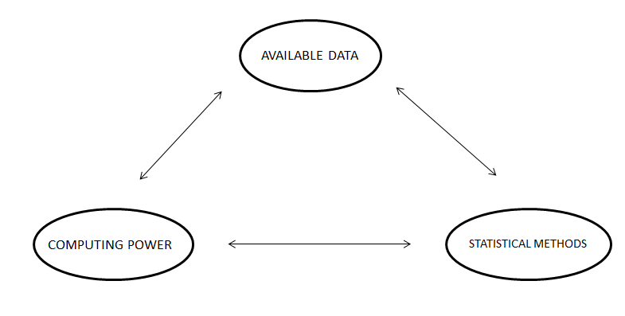

Fig 4.1

**WORKING OF ML :**

Machine learning is made up of 3 parts:-

1. The computational algorithm that works at the crux of making determinations
2. Features and variables that influence the decision
3. Base knowledge for which the answer is known, which helps(trains) the system to learn

In the beginning, the model is fed parameter data for which the answer is known. The algorithm is then run, and adjustments are made until the algorithm’s output (learning) agrees with the known answer. At this point, expanding amounts of data are provided as input to help the system learn and process higher computational decisions.

**How do machines learn?**

The basic learning process is similar. It can be divided into 3 components as follows:

• Data input: It utilizes observation, memory storage, and recall to provide a

factual basis for further reasoning.

• Abstraction: It involves the translation of data into broader representations.

• Generalization: It uses abstracted data to form a basis for action.

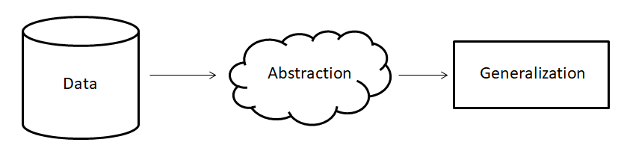

Fig 4.2

**Types of ML Algorithms :**

Based on the type of input available during the training process or the desired outcome, there are 4 main types of machine learning algorithms:-

1. Supervised learning - used in those situations where the output is known, for a particular input; i.e. trained on labeled examples
2. Unsupervised learning - used in those situations where the output is not known, for a particular input;i.e. trained on unlabelled examples
3. Semi-supervised learning - works in those situations in which the combination of supervised and unsupervised learning is required to generate appropriate function or classifier
4. Reinforcement learning - is like a reward/punishment kind of a scenario. Desired manners are rewarded, while undesired ones are punished. Thus the agent behaves in such a way that a sequence of actions that lead to desirable outcomes are produced more times.

**PROBLEMS AND ISSUES IN SUPERVISED LEARNING**

Before getting started,we should judiciously pick an algorithm for use. While picking one,we need to be wary of the following factors **-**

1. Heterogeneity of Data: Many algorithms, such as neural networks and support vector machines, need homogenous numeric and normalised feature vectors. Because algorithms that use distance metrics are extremely sensitive to this, these approaches should be used only as a last resort if the data is diverse. Decision Trees provide a lot of flexibility when it comes to handling diverse data.
2. Data Redundancy: If the data contains redundant information, such as strongly correlated values, distance-based approaches are worthless due to numerical instability. In this circumstance, data can be subjected to some form of regularisation to avoid this problem.
3. Dependent Features: When feature vectors are dependent on one another, algorithms that monitor complicated relationships, such as Neural Networks and Decision Trees, perform better than other algorithms.
4. Bias - Variance Tradeoff : A learning algorithm is biassed for a specific input x if it is systematically incorrect when predicting the correct output for x when trained on each of these data sets, whereas a learning algorithm has high variance for a specific input x if it predicts different output values when trained on different training sets. The total of bias and variance of the learning process may be connected to the prediction error of a learnt classifier, and neither can be large since the prediction error would be high. Machine learning algorithms have the ability to automatically control the balance between bias and variance, or manually tweak the balance using bias parameters, and adopting such methods will remedy this dilemma.
5. The Dimensionality Curse: If the problem has a large number of dimensions and the problem only depends on a subspace of the input space with modest dimensions, the machine learning algorithm may be confused by the large number of dimensions, resulting in a high variance method. In reality, the accuracy of the trained function is likely to increase if the data scientist can manually eliminate unnecessary characteristics from the input data. In addition, several feature selection techniques, such as Principal Component Analysis for unsupervised learning, aim to discover the important characteristics while excluding the unnecessary ones. This decreases the number of dimensions.
6. Overfitting: The programmer should be aware that there is a chance that the output numbers contain inherent noise as a consequence of human or sensor failures. The algorithm must not attempt to infer a function that perfectly matches all of the data in this scenario. Overfitting occurs when the data is fitted too carefully, resulting in the model answering flawlessly for all training instances but with a very high error for unknown samples. Stopping the learning process early and applying filters to the data in the pre-learning phase to reduce sounds are two practical ways to avoid this.

**What is recommendation?**

Recommendation engines are a type of machine learning that deals with ranking or evaluating items or people. A recommender system is a system that anticipates the ratings that a user will give to a certain item. After then, the predictions will be rated and returned to the user.

They are often utilized by huge corporations like Google, Instagram, Spotify, Amazon, Reddit, and Netflix to boost interaction with users and the platform. Spotify, for example, would propose tracks similar to those you've consistently listened to or enjoyed so that you may continue to listen to music on their site. Amazon utilises recommendations to recommend goods to different users depending on the data that Amazon has acquired for that user.

Recommender systems are frequently seen as a "black box," with the models developed by these major corporations being difficult to comprehend. The produced results are frequent recommendations for the user for things that they need / desire but are unaware that they need / want until it is recommended to them.

There are several techniques to develop recommender systems. Some employ algorithmic and formulaic approaches, such as Page Rank, while others use more modeling-centric approaches, such as collaborative filtering, content-based, link prediction, and so on. The complexity of each of these techniques varies, but complexity does not imply "excellent" performance. Simple solutions and implementations frequently produce the best outcomes.

**What is classification?**

The process of recognising, interpreting, and classifying things and thoughts into predetermined groups, often known as "sub-populations," is known as classification. Machine learning systems use a variety of algorithms to classify future datasets into appropriate and relevant categories with the aid of these pre-categorized training datasets.

Input training data is used by classification algorithms in machine learning to predict the likelihood or probability that the data that follows will fall into one of the specified categories. One of the most popular uses of categorization is to sort emails into "spam" and "non-spam" categories, as employed by today's leading email service providers.

To put it another way, categorization is a type of "pattern recognition." In this case, classification algorithms that were applied to the training data detect the same pattern (similar number sequences, words or attitudes, and so on) in subsequent data sets.

**CHAPTER 3**

**Project Implementation**

**DATA PREPROCESSING :**

The preprocessing of the dataset is very much required to support the regulations and syntax which the particular ML model asks for.

The different phases of the preprocessing include :

* Importing of libraries
* Importing the dataset
* Handling the missing data
* Encoding the categorical data
* Encoding the dependent variable
* Splitting the dataset ( Training and test set )
* Feature scaling

**IMPORTING THE LIBRARIES :**

For general use cases the following libraries are imported to support the model structure:

1. **NUMPY**: It will allow us to work with arrays.
2. **MATPLOTLIB**: It will allow us to plot very attractive charts and graphs for visual representation.
3. **PANDAS**: It will allow us to not only import the datasets but also create the matrix of features and dependent variable vectors.

**IMPORTING THE DATASET :**

A new variable is to be created which will contain the exact copy of the dataset we are aiming to deploy. The next target will be creating a data frame. We need to call a function from the panda’s library that is read_csv.

This data frame now created will be the same as the dataset variable.

This is not enough as we have to create two more entities that are:

Matrix of features and the dependent variable vector.

In most of the ML models, the dependent variable is at the end of the dataset and the beginning comprises the matrix of features.

**HANDLING THE MISSING DATA :**

We try to replace the missing values with the average of all the values in that particular column.

We take help from a reputed data science library that is SCIKIT LEARN.

Inside that, we take the help of a module named IMPUTE. We now create a tool/method in the object imputer to connect the object to the matrix of features.

Now the imputer transform replaces the missing values with the mean value and is stored or returned to the dataset portion which had the missing values.

**ENCODING THE CATEGORICAL DATA**

We try to encode the strings to certain numbers to let the ML model understand them and establish a correlation between them.

The encoding procedure used here is *ONE HOT ENCODING* ( which allows the representation of categorical data to be more expressive )

**ENCODING THE DEPENDENT VARIABLE**

LabelEncoder is a class in the pre-processing module of the scikit learn library that has no arguments if the dependent variable had only 2 categories. So we can just encode them into 1 and 0.

**SPLITTING THE DATASET**

The dataset is generally split into the Training set and Test set.

**Training set**: To train the ML model with the sets of data to identify attributes and features and patterns of the data.

**Test set**: To test the ML model with the new feature data to do performance monitoring.

We need to specify the test size to clarify how much % of the dataset we want in the test set and the remaining in the training set.

We set the random_state as 1 to choose the data from the dataset randomly so that we just do not feel lucky just for this particular dataset.

**FEATURE SCALING :**

In ML models, some of the features dominate over some of the features. To tackle this problem feature scaling is important.

Feature scaling is not required for all ML models; it is a model-specific procedure.

The method of feature scaling is Standardisation and Normalisation.

Normalization is usually preferred and recommended where we have a normal distribution in most of the features.

We don’t need feature scaling when the data is encoded or binary data.

**ASSOCIATION RULE LEARNING :**

Associative rule learning is a category of unsupervised learning that examines the dependency relationship between two data items and maps them appropriately so that benefit may be gained. It does so by looking for any relevant relationships or linkages among the dataset's variables. It also uses a variety of criteria to look for intriguing connections between the database's variables.

**Working:-**

Association learning works on the if-else concept.

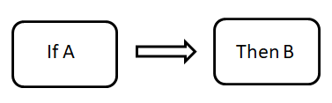

Fig 4.3

The If element of association is called the Antecedent.

The Then statement is called the Consequent.

This type of relationship is called Single Cardinality.

The key parameters to find the association is:

1. **Support,**
2. **Confidence and**
3. **Lift**

**Support**

The frequency of X, or the frequency with which a certain item shows up in the dataset, is known as support. The amount of the transaction T that is made up of the itemset X is what we use to calculate this value. The following may be expressed for transactions T if X datasets exist:

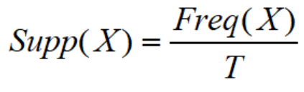

**Confidence**

The frequency with which a rule holds true is indicated by its confidence. In other words, number of times X and Y appear in a dataset where X is known. In other words, it's the set of items that include X divided by the number of transactions that include X.



**Lift**

Lift is the Rule strength. It may be determined using the following formula:



If X and Y are independent of each other, Lift is the ratio between the actual support measure and the predicted support. It can be one of three things:

* **Lift = 1**: The probability of occurrence of antecedent and consequent is independent of each other.
* **Lift > 1**: It determines the degree to which the two itemsets are dependent on each other.
* **Lift < 1**: It tells us that one item is a substitute for other items, which means one item hurts another.

**Apriori Model specifications:**

In this project, we have used the Apriori model for recommending the medicine combination that the customer is most likely to buy.

The Apriori algorithm, given by R.Agrawal and Srikant in the year 1994, uses recurrent itemsets to develop association rules. It is mainly designed to work on databases that contain transactions. Using these rules, it is possible to determine how strongly or how weakly these objects are connected.

To calculate the associations effectively, the Apriori algorithm uses a Hash tree and a breadth-first search to find frequent items from a large dataset, iteratively,often known as level-wise search, in which k-frequent itemsets are used to find k+1 itemsets.

An important attribute called the Apriori property is utilized to improve the efficiency of level-wise generation of frequent itemsets by minimizing the search space.

**Apriori Property** is a term that refers to a property that exists before it.

All subsets of the frequent itemset that aren't empty must be frequent. The anti-monotonicity of the support measure is a crucial concept in the Apriori algorithm.

In Apriori, it is assumed that -

**A frequent itemset's subgroups must all be frequent (Apriori property).**

**If an itemset is rare, all of its supersets are rare as well.**

**What is a Frequent Itemset?**

Frequent itemsets are ones that receive more support than the threshold limit or otherwise known as user-specified minimum support. In other words, if X and Y are the most common sets collectively, then X and Y should be the most common set separately.

Eg - Assume there are 2 itemsets X{2,4,7,8} and Y{3,4,5,8}. In these two transactions, {4,8} are the frequent itemsets.

**Eclat model :-**

The ECLAT algorithm stands for Equivalence Class Clustering and bottom-up Lattice Traversal.

It is one of the most often used Association Rule mining techniques. It's a more scalable and efficient variant of the Apriori method. The Apriori method operates in a horizontal sense, simulating a graph's Breadth-First Search, whereas the ECLAT algorithm works in a vertical sense, simulating a graph's Depth-First Search. The ECLAT algorithm is faster than the Apriori algorithm because of its vertical approach.

The ECLAT model only comprises the support parameter , here we will be talking only about sets in a specific manner . There will be a set of two or more tasks which need to be analysed and fit into the model for smooth functioning . Here we need to set a minimum support and then take in account all the subsets in transactions having support less than minimum support and then we need to sort these according to decreasing order of support .

**Working:-**

The primary idea is to compute a candidate's support value using Transaction Id Sets(tidsets) intersections rather than generating subsets that don't exist in the prefix tree. All single items, as well as their tidsets, are used in the function's first call. The function is then executed recursively, with each recursive call verifying and combining item-tidset pairings with additional item-tidset pairs. This method is repeated until there are no more candidate item-tidset pairings to combine.

Here we need to set a minimum support and then take in account all the subsets in transactions having support less than minimum support and then we need to sort these according to decreasing order of support .

We just need to organise the list into a Pandas Dataframe and we don't need to create tuples for the confidence and lift section .

Let's look at an example of the above-mentioned working:

|  |  |  |  |  |  |
| --- | --- | --- | --- | --- | --- |
| Transaction id | Bread | Jam | Milk | Butter | Chips |
| T10 | 1 | 1 | 0 | 0 | 1 |
| T11 | 0 | 1 | 0 | 1 | 0 |
| T12 | 0 | 1 | 1 | 0 | 0 |
| T13 | 1 | 1 | 0 | 1 | 0 |
| T14 | 0 | 1 | 1 | 0 | 0 |
| T15 | 1 | 0 | 1 | 0 | 0 |
| T16 | 1 | 1 | 1 | 0 | 1 |
| T17 | 1 | 1 | 1 | 0 | 0 |

The above data is a boolean matrix, with the value indicating whether the j'th item is included in the i'th transaction or not for each cell I j). 1 denotes truth, while 0 denotes falsity.

For the first time, we call the function and arrange each item with its tidset in a tabular fashion:-

**k = 1, minimum support = 2**

|  |  |
| --- | --- |
| **Itemset** | **Transaction ID Set** |
| **Bread** | **{T10,T13,T15,T16,T17}** |
| **Jam** | **{T10,T11,T12,T13,T14,T16,T17}** |
| **Milk** | **{T12,T14,T15,T16,T17}** |
| **Butter** | **{T11,T13}** |
| **Chips** | **{T10,T16}** |

We now recursively call the function till no more item-tidset pairs can be combined**:-**

**k = 2**

|  |  |
| --- | --- |
| **Itemset** | **Transaction ID Set** |
| **Bread,Jam** | **{T10,T13,T16,T17}** |
| **Bread,Milk** | **{T15,T16,T17}** |
| **Bread,Butter** | **{T13}** |
| **Bread,Chips** | **{T10,T16}** |
| **Jam,Milk** | **{T12,T14,T16,T17}** |
| **Jam,Butter** | **{T11,T13}** |
| **Jam,Chips** | **{T10,T16}** |
| **Milk,Chips** | **{T16}** |

**k = 3**

|  |  |
| --- | --- |
| **Itemset** | **Transaction ID sets** |
| **{Bread,Jam,Milk}** | **{T16,T17}** |
| **{Bread,Jam,Chips}** | **{T10,T16}** |

**k = 4**

|  |  |
| --- | --- |
| **Itemset** | **Transaction ID sets** |
| **{Bread,Jam,Milk,Chips}** | **{T16}** |

Because there are no more item-tidset pairs to merge, stop at k = 4.

Because the supplied dataset has a minimum support of 2, the following rules can be derived:-

|  |  |
| --- | --- |
| **Items Bought** | **Recommended Products** |
| **Bread** | **Jam** |
| **Bread** | **Milk** |
| **Bread** | **Chips** |
| **Jam** | **Milk** |
| **Jam** | **Butter** |
| **Jam** | **Chips** |
| **Bread and jam** | **Milk** |
| **Bread and jam** | **Chips** |

**WORKING OF APRIORI MODEL :**

The following are the steps of the Apriori algorithm:-

1. Identify things present in the transactional database that have support and then pick the ones with the least amount of trust and support.
2. Identify all of the data points that have a support value greater than the currently specified or minimum support value.
3. Be sure to take note of any subset rules whose confidence value exceeds the threshold limit.
4. In descending order of lift, arrange the rules in the database.
5. As the elevator moves down the list, we'll have a clearer picture of the connections between the drugs.

**Dataset:**

In the first part, we created a dataset that simulates the transaction data of a pharmacy's customers. Rows indicate each transaction and contain the list of drugs purchased by the individual in question, totaling 7500.

This dataset comprises E. Coli promoter gene sequences (DNA) with incomplete domain theory from the UCI Molecular Biology (Promoter Gene Sequences) dataset.

The description of the attribute is as follows -

1. One of {+/-}, indicating the class ("+" = promoter).

2. The instance name (non-promoters named by position in the 1500-long nucleotide sequence provided by T. Record).

3-59. The remaining 57 fields are the sequence, starting at position -50 (p-50) and ending at position +7 (p7). Each of these fields is filled by one of {a, g, t, c}.

**PROPOSED MODEL**

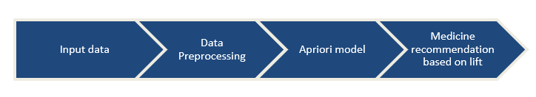

**Fig 4.4 - Workflow of the Apriori model**

The goal of this research is to use machine learning to help with drug supply. Using the Apriori algorithm's support metrics, the goal is to create a recommendation system for the medicine that a specific customer is most likely to buy, resulting in a win-win situation for both the customer and the shop owner: the customer gets the most appropriate medicine they want at all times and does not have to deal with the problems of out-of-stock medicines; and the pharmacist learns the specific combination of medicines that is made available quickly. A lack of drug supply implies the involvement of medical black market is drastically reduced. The complete workflow of the proposed model is given in Fig.4.4 .

**Classification Models**

1. **Naive Bayes -**

Naive Bayes is a classification technique based on the assumption that predictors in a dataset are unrelated. This implies that the traits are unconnected to one another. When given a banana, for example, the classifier will notice that the fruit is yellow in colour, rectangular in shape, and long and tapered. All of these characteristics will add to the likelihood of it becoming a banana in their own right and are not reliant on one another. The naive Bayes algorithm is based on Bayes' theorem, which is as follows:

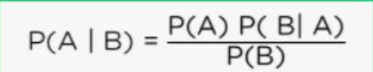

Where :

P(A | B) = probability of A occurring if B occurs

P(A) = probability that A will occur

P(B) = probability that B will occur

P(B | A) = probability of B occurring if A occurs

1. Decision Trees:

A visual depiction of decision-making is a decision tree. Creating an option tree begins with providing a yes/no question and then dividing the answer into two pieces. Nodes and leaves are both involved in the decision-making process. Internal nodes indicate dataset properties; branches indicate decision rules; and each leaf node denotes outcome from the classification process.

The Decision Node and the Leaf Node are the two nodes that make up a decision tree. Leaf nodes are the outcomes of decisions, while Decision nodes are the means by which decisions are made. Decision nodes contain several branches, whilst Leaf nodes have none.

The evaluations or tests are made depending on the data given. It's a visual representation of all the alternative workable solutions to complex problems or choices, based on particular parameters being satisfied or not met.

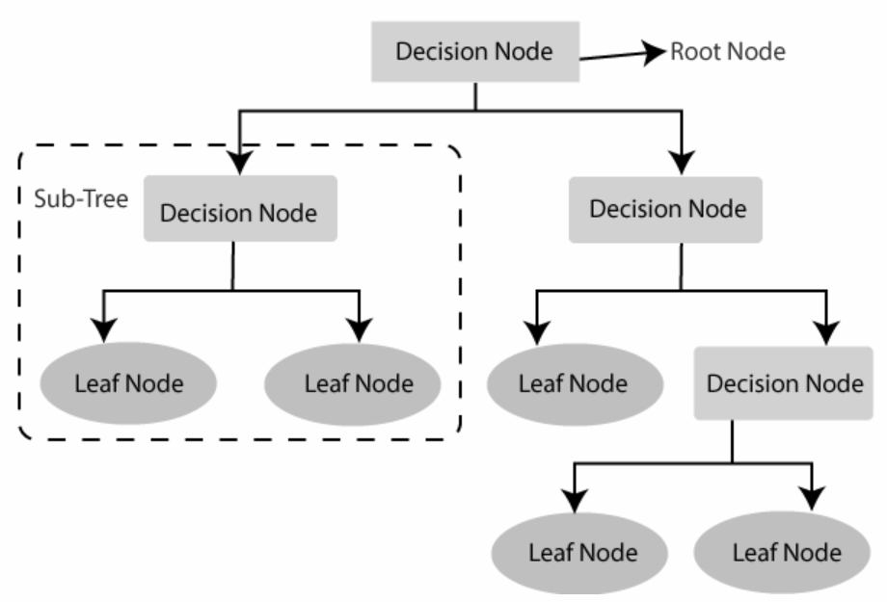

Fig - Decision tree structure

1. **Gaussian Classifier: (Radial basis function)**

Gaussian Processes are an extension of the Gaussian probability distribution that may be used to create advanced non-parametric machine learning algorithms for classification and regression.

For classification predictive modelling, Gaussian processes can be employed as a machine learning method.Gaussian processes, like SVMs, are a form of kernel approach, however unlike SVMs, they can predict highly calibrated probabilities.

Gaussian processes need the specification of a kernel that governs how samples relate to one another; particularly, it determines the data's covariance function. This is referred to as the latent function or "nuisance" function. The Gaussian Processes Classifier is a non-parametric technique for binary classification applications.

1. **K-Nearest Neighbour:**

K-Nearest Neighbor is a basic Machine Learning method that uses the Supervised Learning approach. The K-NN method assumes similarity between the new case/data and existing cases and places the new case in the category that is most similar to the existing categories.The K-NN algorithm maintains all existing data and classifies new data points based on similarities. This implies that when fresh data is generated, it may be quickly categorised into a well-suited category using the K- NN method.

The K-NN approach may be used for both regression and classification, however it is more commonly utilised for classification tasks.K-NN is a non-parametric method, which means it makes no assumptions about the underlying data.

1. **Random Forest:**

One of the most popular machine learning algorithms belonging to the supervised learning method is Random Forest. In machine learning, it may be used for both regression and classification problems. In order to deal with a complex problem and improve the precision, ensemble training, which combines many classifiers, is used.

Random Forest is a classifier that comprises a number of decision trees on various subsets of the provided dataset and takes the average to enhance the predicted accuracy of that dataset Instead of depending on a single decision tree, the random forest collects the forecasts from each tree and predicts the final output based on the majority vote of predictions.

The bigger the number of trees in the forest, the higher the accuracy and the lower the risk of overfitting.

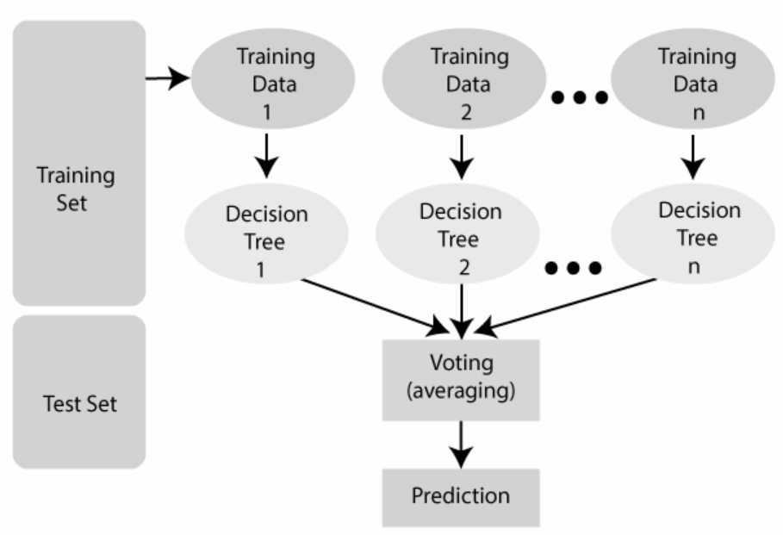

Fig - Working of random forest

**Evaluating Classification Algorithms**

Some accuracy measurements are needed to assess the accuracy of any classifier model. To test how effectively the classifiers predict, the following methods are utilised:

1. Method of Withholding/Holdout Method - It is one of the most popular ways of determining how accurate classifiers are. The data is divided into two sets in this method: a Training set and a Testing set. The model is presented with the training set, and it learns from the data in it. The data in the testing set is concealed from the model, and the testing set is used to test the model's accuracy after it has been trained.

The features and related label will be included in the training set, but just the features will be present in the testing set, and the model will have to predict the appropriate label.

The predicted labels are then compared to the real labels, and the model's accuracy is determined by counting how many labels it correctly predicted.

1. Using Bias and Variance - The gap between actual and expected numbers is known as bias. The model's bias is the basic assumptions it makes about the data in order to forecast fresh data. It is a perfect match for the patterns observed in the data. When the Bias is large, the model's assumptions are too simple, and the model is unable to capture the significant properties of our data; this is referred to as underfitting.

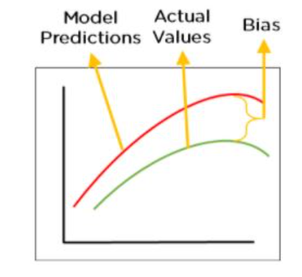Fig - Bias

Variance may be defined as the model's sensitivity to data variations. The model might be able to learn from the noise. As a result, it will value insignificant characteristics. When the variance is large, the model will collect all of the features of the data supplied to it, adjust itself to the data, and forecast accurately on it; but, fresh data may not have the same features, and the model will be unable to predict accurately on it. This is what is known as the variance.

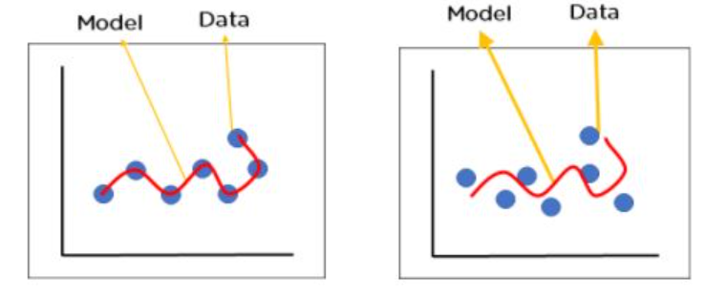

Fig - Example of Variance

1. Precision and Recall - Precision is used to determine a model's ability to properly categorise values. It is calculated by dividing the total number of correctly categorised data points for that class label by the number of correctly classified data points.

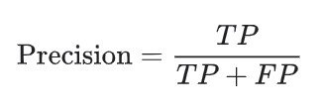 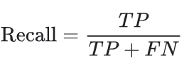

When and where:

A true positive(TP) result is one in which the model accurately predicts the positive class. A true negative(TN), on the other hand, is a result in which the model properly predicts the negative class.

A false positive(FP) is an outcome in which the model forecasts the positive class inaccurately. A false negative(FN) is an outcome in which the model forecasts the negative class inaccurately.

The capacity of the mode to anticipate positive values is measured by recall. It is a measure of how often the model forecasts true positive values. The ratio of genuine positives to the total number of real positive values is used to compute this value.

1. F1 - Score - The weighted harmonic mean of accuracy and recall is the F1. The closer the F1 score number is to 1.0, the higher the model's projected performance.

F1 Score = 2*(Recall * Precision) / (Recall + Precision)

Support - The number of actual instances of the class in the dataset is referred to as support. It does not differ between models; it just diagnoses the process of performance evaluation.

Imbalanced support in the training data may suggest fundamental problems in the classifier's reported scores, indicating the necessity for stratified sampling or rebalancing. The support does not differ between models, but rather diagnoses the evaluation process.

A classification report is a machine learning performance evaluation statistic. It is used to display the trained classification model's accuracy, recall, F1 Score, and support.True and false positives, as well as true and false negatives, are used to generate the metrics. In this scenario, positive and negative are general names for the projected classes.

**CHAPTER 4**

**Results and Discussion**

**Part 1 (A)**

**Apriori Recommendation system :**

Word Cloud showing the most popular items

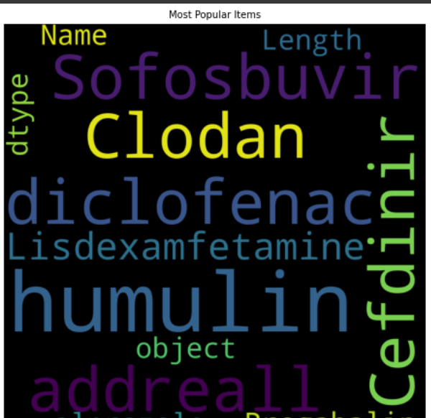

**Frequency of the most popular items :**

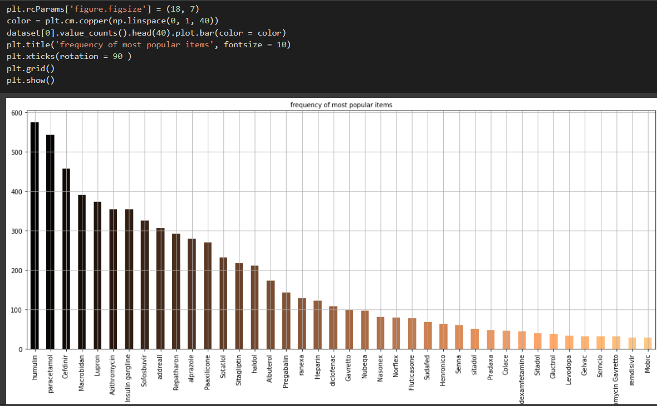

**Displaying the results**

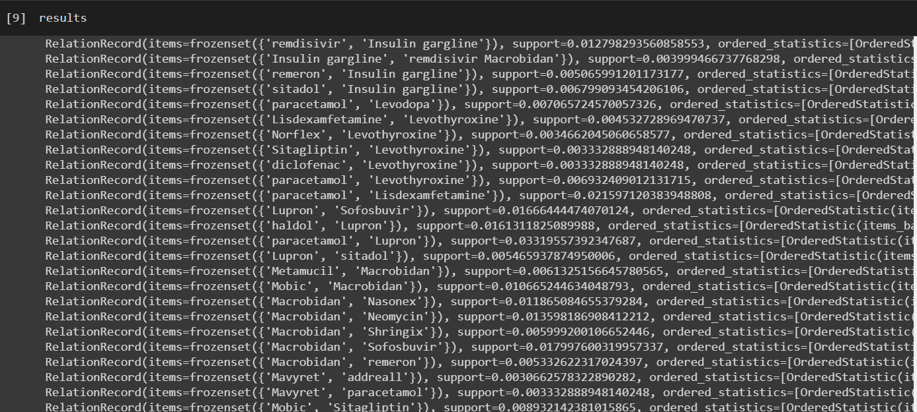

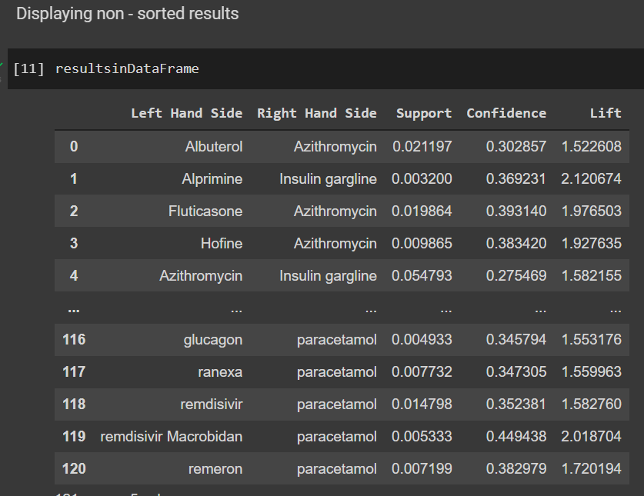

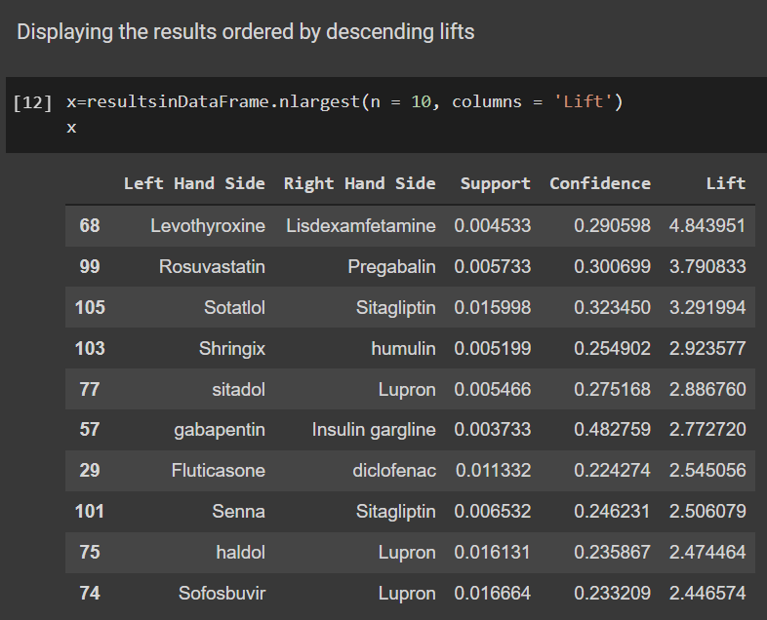

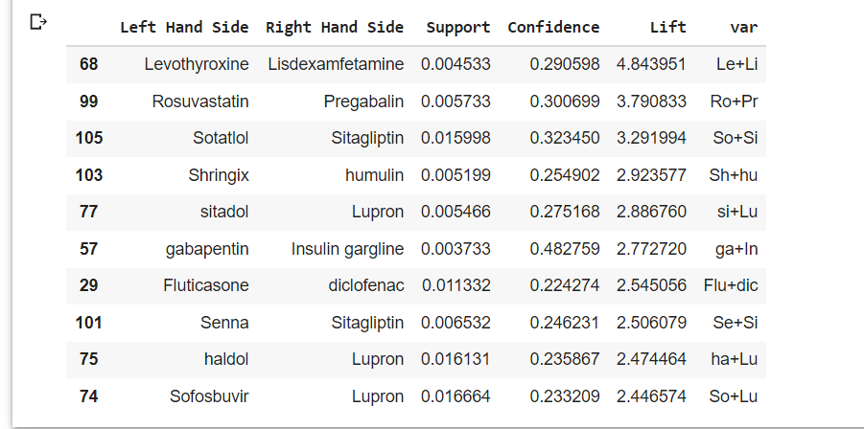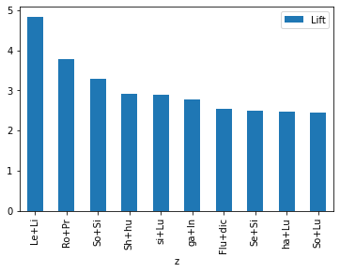

**1(B)**

**ECLAT Recommendation system :**

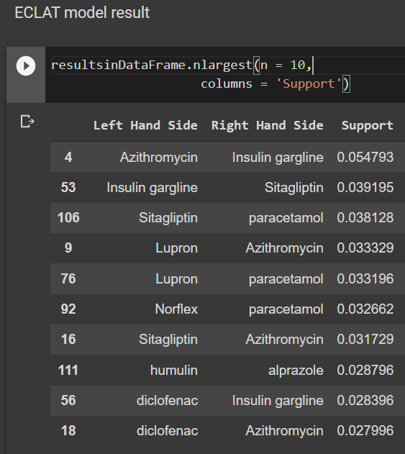

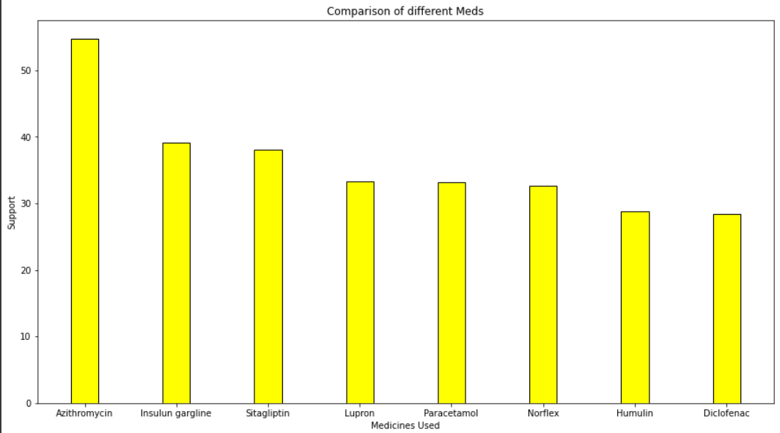

**Fig - ECLAT model result visuals**

There are two types of association rule mining algorithms now available: horizontal format mining algorithms and vertical format mining algorithms. We have a matrix that displays transactions with objects; this type of matrix can be displayed horizontally or vertically.

The horizontal data arrangement is the most widely utilized. Each transaction, in other words, contains a transaction identifier (TID) and a list of items that occur in that transaction, i.e., TID:itemset. The vertical data structure, in which the database consists of a set of items, each followed by the set of transaction IDs containing the item, i.e., item:TID set, is another often used layout. The horizontal configuration is shown in table 1; the vertical layout is shown in table 2:

|  |  |
| --- | --- |
| TRANSACTION ID | ITEMSETS |
| T1 | Milk , Biscuit, Sauce |
| T2 | Milk Sauce |
| T3 | Slice |

Table 1:Horizontal Format

|  |  |
| --- | --- |
| ITEMSET | TRANSACTION |
| Milk | T1 , T2 |
| Biscuit | T1 |
| Sauce | T1,T2 |
| Slice | T3 |

Table 2:Vertical format

Apriori algorithm uses horizontal format while Eclat can be used only for vertical format data sets. A number of vertical mining algorithms have been proposed recently for association mining, which has shown to be very effective and usually outperform horizontal approaches.

The Eclat algorithm is a data mining algorithm for locating frequently occurring things. As we already know, certain association rule mining algorithms generate frequent itemsets using a horizontal data format, while others use a vertical data format. Eclat is unable to make use of a horizontal database. If a horizontal database exists, it must be converted to a vertical database.

The ECLAT algorithm is faster than the Apriori algorithm because of its vertical approach (but sometimes when intermediate results of vertical tid lists become too large for memory, it can affect the algorithm's scalability). We need to search the database repeatedly in the Apriori technique to locate common itemsets; this limitation is alleviated in Eclat by employing a vertical dataset. Only one scan of the database is required by Eclat.

While the Apriori algorithm imitates a graph's Breadth-First Search in a horizontal sense, the ECLAT method imitates a graph's Depth-First Search in a vertical sense, which is usually faster than Breadth-First search.

Eclat represents transactions entirely vertically. To compute the support, no subset tests or subset generation are required. In most cases, Transaction Id sets (also known as tidsets) are utilized to calculate the Support value. Intersecting transaction lists determine the item sets' support.

All single items of data, as well as their respective tidsets, are used in the first invocation of the function. The function is then called recursive, and each item in the tidsets pair is validated and combined with the other items in the tidsets pair in each recursive call. This operation is performed until there are no more candidate items in tidsets pairs to merge.

The vertical format's key benefit is that it supports fast frequency counting using intersection operations on transaction ids (tids) and automatic data trimming. The fundamental issue with these approaches is that as the intermediate results of vertical tid lists grow too large for memory, the algorithm's scalability suffers.

In short we can say that ,

the Eclat algorithm is naturally faster than the Apriori algorithm when the data set size is small or medium. There is a chance that Apriori will perform better when the data set size is large, because intermediate Tidsets created by the Eclat algorithm consume more memory than Apriori. In cases where we have a large dataset, intermediate results of vertical tid lists become too large for memory, affecting the algorithm scalability. As a result, the Eclat method is superior for small and medium datasets, whereas the Apriori approach is better for large datasets.

**2**

**Classification algorithms :**

The classification report of each model is included below,which prints the mean and standard deviation of the values.

The accuracy of the classification algorithm can be viewed just below,as a percentage.

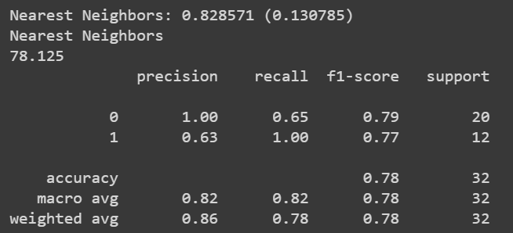

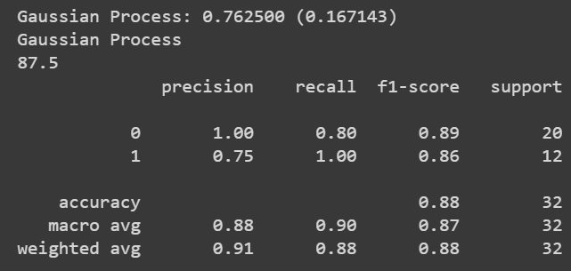

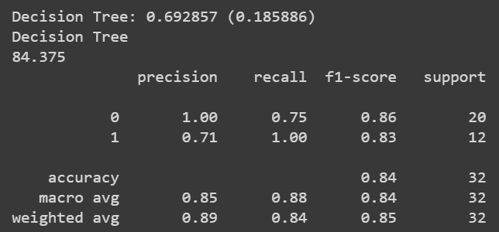

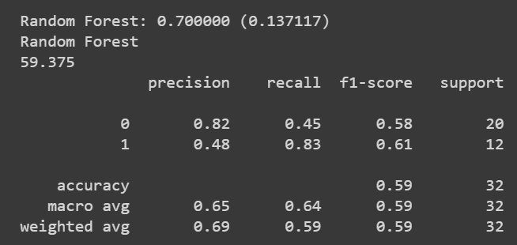

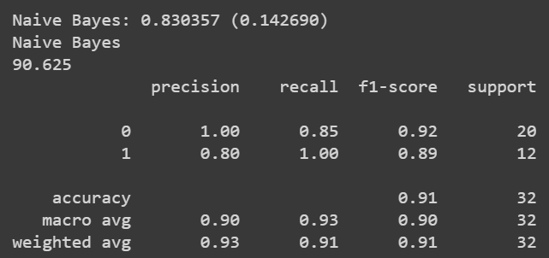

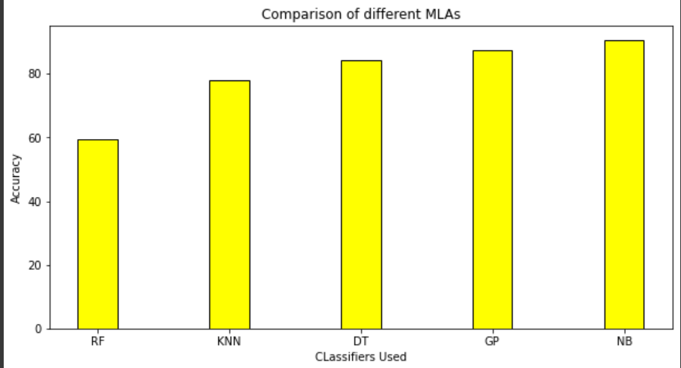

The best model for this particular classification is the Naive-Bayesian algorithm with an accuracy of 90.625%.

**CHAPTER 6**

**CONCLUSION AND FUTURE SCOPE**

* 1. **Summary:-**

We have mainly focused on two objectives. The first one was a medicine recommendation system that will be helpful for the healthcare sector. People won’t have to face the problem of unavailable medicines, since the stores will be stocked well in advance since they can know which medicines are most likely to be bought. Moreover, the economy will be helped since the medical black market will be eliminated as medicines are readily available so there is no shortage, thus no scope of dishonest people to dupe others by profiteering from selling medicines at exorbitant rates to needy people. Secondly,our focus is on the study and comparison of various classifiers. We have taken 5 classifiers and processed the same dataset containing DNA sequences through each of them,so that we can understand which classifier works best in our case.

However, there are a few shortcomings to the recommendation too. Basic knowledge of the operation is to be learned by the caregivers. Furthermore, the drugs that have been anticipated may not always be available, and individuals may require additional medications. People might be allergic to the medicines that are being recommended together,thus requiring other types of medicines.

The classifier system is fairly accurate,but not foolproof. It might not work well with variations in data or there might be mislabeled data,leading to difficulties in maintaining compliance. In worst cases,there might be natural disasters or other difficulties that disrupt the entire structure,causing extensive damage and going back to the start all over again.

**6.2 Future Scope:-**

The main motive behind this model is to ensure that the common people get the best possible variant of the medicines available in the market at all points of time.

This model will just recommend the best associated combination of medicines that go along with each other in a certain manner based on the previous sales of those medicines. Thus it thereby allows the optimal transaction to happen between the patient and the chemist shop.

On the flip side , it also allows the chemist to update his/her stocks to its full potential at any given point in time so that the patient can get the best possible variants of the medicines , whenever he/she has a necessity of it .

In future, the proposed apriori based machine learning recommendation model can be enhanced to allow low infrastructural casualties in a healthcare center as it will always ensure that the best possible medicine or other health equipment are available at all times of the year . This will boost the lack of technical and managerial policies that are lacking today in different healthcare centres across India .

Because of the effects of globalisation and high mobilisation of the global population, new viruses are expected to originate and spread as quickly as the present COVID-19. Identifying infections sooner will aid in the prevention of outbreaks such as COVID-19 and will aid in medication development. As a result, DNA sequence categorization is critical in computational biology. Our classification model tries to explore different classifiers and ascertain which classifier works best in our case. Thereafter in future the tests can be performed on a larger dataset and studied in detail.

This model can be further enhanced by focussing on the UI/UX aspect which will allow a patient and his/her family to get a clear visual understanding of the current status of the different healthcare facilities that are available at a healthcare center in some developed areas without even travelling long distances in search of a preferable diagnostic centre for the patient .

This method will save many lives and, as a result, lead to a better policymaking mindset for the general public..

**CHAPTER 7**

**PLANNING & REFERENCES**

**7.1 Planning and project management**

|  |  |  |  |
| --- | --- | --- | --- |
| S.No. | Activity | Starting Week | Number of Weeks |
| 1. | Literature Review | 1st-2nd week of Dec | 2 |
| 2. | Required software setup, coding,calibration | 3rd week of  Dec | 1 |
| 3. | Code Integration & Debugging | 1st week of Jan | 1 |
| 4. | Inclusion of ECLAT model | 2nd week of Jan | 1 |
| 5. | Medicine overview along with a basic understanding of python and data manipulation and preprocessing | 3rd week of  Jan | 1 |
| 6. | Preparing the model(train) | 4th week of Jan | 2 |
| 7. | Fitting model | 2nd week of Feb | 1 |
| 8. | Checking model | 3rd week of Feb | 1 |
| 9. | Analysis after training the model | 4th week of Mar | 2 |
| 10. | Metrics evaluation | 2nd week of Mar | 1 |
| 11. | Preparation of project report | 3rd week of  Mar | 2 |
| 12. | Preparation of Project presentation | 1st week of Apr | 1 |

**The Gantt Chart is shown below:-**

Total weeks

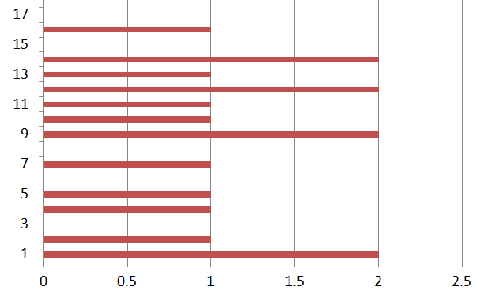No.of indiv. weeks

**7.2 REFERENCES –**

[1].J. Bouwens, “Embracing Change: The healthcare industry focuses on new growth drivers and leadership requirements.”

[2]. "Intro to Machine Learning | Udacity." Intro to Machine Learning | Udacity. Accessed April 27, 2016.

[3]. Thanh Nguyen, Abbas Khosravi, Douglas Creighton, Saeid Nahavandi,

Classification of healthcare data using genetic fuzzy logic system and wavelets,

Expert Systems with Applications, Volume 42, Issue 4, 2015, Pages 2184-2197

[4]. Schölkopf, Bernhard, Christopher J. C. Burges, and Alexander J. Smola,Advances in Kernel Methods: Support Vector Learning. Cambridge, MA: MIT Press, 1999.

[5]. Witten, I. H., and Eibe Frank. Data Mining: Practical Machine Learning Tools and

Techniques. Amsterdam: Morgan Kaufman, 2005

[6]. Zhiyong Ma, Juncheng Yang, Taixia Zhang, Fan Liu. (2016). An Improved Eclat Algorithm for Mining Association Rules Based on Increased Search Strategy. International Journal of Database Theory and Application, 9(5), 251-266

[7]. Yoo I, Alafaireet P, Marinov M, Pena-Hernandez K, Gopidi R, Chang JF, et al. Data mining in healthcare and biomedicine: a survey of the literature. J Med Syst 2012; 36:2431–48.

[8]. Yadav M, Malhotra P, Vig L, Sriram K, Shroff G. Ode-augmented training improves anomaly detection in sensor data from machines. arXiv preprint arXiv:1605.01534,2016:1–5.

[9]. Hastie, Trevor, Robert Tibshirani, and J. H. Friedman. The Elements of Statistical

Learning: Data Mining, Inference, and Prediction: With 200 Full-color Illustrations. New York: Springer, 2001

[10]. O.Stephen et.al.,”An Efficient Deep Learning Approach to Pneumonia Classification in Healthcare”,Journal of Healthcare Engineering ,Volume 2019

[11]. P. S. Mung and S. Phyu. Effective analytics on healthcare big data using ensemble learning. In 2020 IEEE Conference on Computer Applications(ICCA), pages 1–4, 2020.

##### [12]. Samer Ellahham, Artificial intelligence in the diagnosis and management of COVID-19: a narrative review, *Journal of Medical Artificial Intelligence*,2021

[13]. Dave DeCaprio, Joseph Gartner, Carol J. McCall, Thadeus Burgess, Kristian Garcia, Sarthak Kothari, Shaayaan Sayed, Building a COVID-19 vulnerability index, *Journal of Medical Artificial Intelligence*,2020

[14]. Pahulpreet Singh Kohli and Shriya Arora. Application of machine learning in disease prediction. In 2018 4th International Conference on Computing Communication and Automation (ICCCA), pages 1–4. IEEE, 2018.

[15]. Munira Ferdous, Jui Debnath and Narayan Ranjan Chakraborty, Machine Learning Algorithms in Healthcare: A Literature Survey, In, that on 2020 11th International Conference on Computing, Communication, and Networking Technologies (ICCCNT)

[16]. Shweta Ganiger and KMM Rajashekharaiah. Chronic diseases diagnosis using machine learning. In 2018 International Conference on Circuits and Systems in Digital Enterprise Technology (ICCSDET), pages 1–6. IEEE, 2018.

[17]. Dharavath Ramesh, Pranshu Suraj, and Lokendra Saini. Big data analytics in healthcare: A survey approach. In 2016 International Conference on Microelectronics, Computing and Communications (MicroCom), pages 1–6. IEEE, 2016

[18]. Kumar SP, Samson VRR, Sai UB, Rao PLSDM, Eswar KK. Smart health monitoring system of patient through IoT. In: 2017 International conference on I-SMAC (IoT in social, mobile, analytics and cloud) (I-SMAC). IEEE; 2017. p. 551–6.

[19]. Trivedi S, Cheeran AN. Android based health parameter monitoring. In: *2017 International conference on intelligent computing and control systems (ICICCS).* IEEE; 2017. p. 1145–9

[20]. Acharya AD, Patil SN. IoT based health care monitoring kit. In: 2020 Fourth international conference on computing methodologies and communication (ICCMC). IEEE; 2020. p. 363–8.

[21]. Geron, “Hands-On Machine Learning with Scikit-Learn, Keras, and TensorFlow”, O’Reilly Media, Inc., Canada, 2019

[22]. William W, Basaza-Ejiri AH, Obungoloch J, Ware A. A review of applications of image analysis and machine learning techniques in automated diagnosis and

classification of cervical cancer from pap-smear images.

[23].T. I. Mohammad, A. A. Md, T. M. Ahmed, and A. Khalid, “Abnormality detection and localization in chest x-rays using deep convolutional neural networks,” 2017, <http://arxiv.org/abs/1705.09850>.

[24].P. Huang, S. Park, R. Yan et al., “Added value of computer-aided CT image features for early lung cancer diagnosis with small pulmonary nodules: a matched case-control study,” *Radiology*, vol. 286, no. 1, pp. 286–295, 2017.

[25].G. Varun, P. Lily, C. Marc et al., “Development and validation of a deep learning algorithm for detection of diabetic retinopathy in retinal fundus photographs,” *JAMA*, vol. 316, no. 22, pp. 2402–2410, 2017

[26].J. Melendez, G. B. Van, P. Maduskar et al., “A novel multiple-instance learning-based approach to computer-aided detection of tuberculosis on chest x-ray,” *IEEE Transactions on Medical Imaging*, vol. 34, no. 1, pp. 179–192, 2015.

[27].U. Avni, H. Greenspan, E. Konen, M. Sharon, and J. Gold-berger, “X-ray categorization and retrieval on the organ and pathology level, using patch-based visual words,” *Med Imaging, IEEE Transactions*, vol. 30, no. 3, 2011.

[28].H. Boussaid and I. Kokkinos, “Fast and exact: ADMM-based discriminative shape segmentation with loopy part models,” in *Proceedings of Conference on Computer Vision and Pattern Recognition (CVPR)*, Columbus, OH, USA, June 2014

**SELF DECLARATION FOR PLAGIARISM CHECK**

We, Souvik Karmakar(1807228), Sudeshna Dutta(1807232),Indrashis Mitra(1807274), Kinjal Sarkar(1807277) and Pratyay Basu(1807291) are declaring that our Project report on “A COMPARATIVE ANALYSIS OF MACHINE LEARNING ALGORITHMS” has plagiarism well within the limits prescribed to us. We take full responsibility for it.